**1. Using Insert Function, give examples of any function available in the different dropdowns present in the function library. For example AutoSum, Recently Used, Text, Date & Time, etc.**

**2. What are the different ways you can select columns and rows?**

**3. What is AutoFit and why do we use it?**

**4. How can you insert new rows and columns into the existing table?**

**5. How do you hide and unhide columns in excel?**

**6. Create an appropriate table within the worksheet and use different functions available in the AutoSum command.**

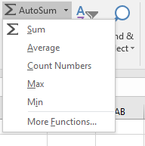**A1.** On the Home ribbon, click on the arrow next to the AutoSum icon and select More Functions

Go to the Formulas ribbon – choose either the Insert Function icon to bring up the Insert Function dialog box (same dialog box we would get with the first method), or click the arrow next to the correct category in the Function Library Group, and then choose the desired function.

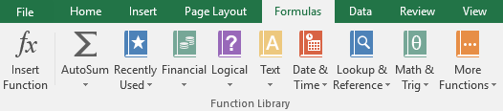

**A2**. Or click on any cell in the column and then press Ctrl + Space. Select the row number to select the entire row. Or click on any cell in the row and then press Shift + Space. To select non-adjacent rows or columns, hold Ctrl and select the row or column numbers.

**A3.** AutoFit is a feature in Excel that allows you to quickly adjust the row height or column width to fit the text completely (so that there is no spilling over to other cells). Autofit Row Height: This feature automatically adjusts the row height to fit the text in the cell. You can autofit multiple rows at once.

**A4.** Add a row or column

Click where you want in your table to add a row or column and then click the Layout tab (this is the tab next to the Table Design tab on the ribbon).

To add rows, click Insert Above or Insert Below and to add columns, click Insert Left or Insert Right.

**A5.** On the Home tab, in the Cells group, click Format. Do one of the following: Under Visibility, click Hide & Unhide, and then click Unhide Rows or Unhide Columns.

**A6.**

. 